**PathFinder 600**

Beam coordinate systems: EX command (see more at EA and EP commands in mechanical integration considerations)

Alignment: EA command is meant to describe the rotation between instrument Y axis (beam 3) and ship forward axis

Ping timing: When the maximum operating altitude is known, the BX command can be used to limit the maximum ping time in Bottom Track mode, since time to receive data from the bottom is proportional to the distance to the bottom.

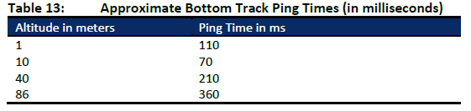

System synchronization: synchronization be achieved using a hardware trigger (CX1 or CX2 command) with the data time-tagged with the navigation system time recorded at the time of the hardware trig-ger.

Triggering: CF or CX command !

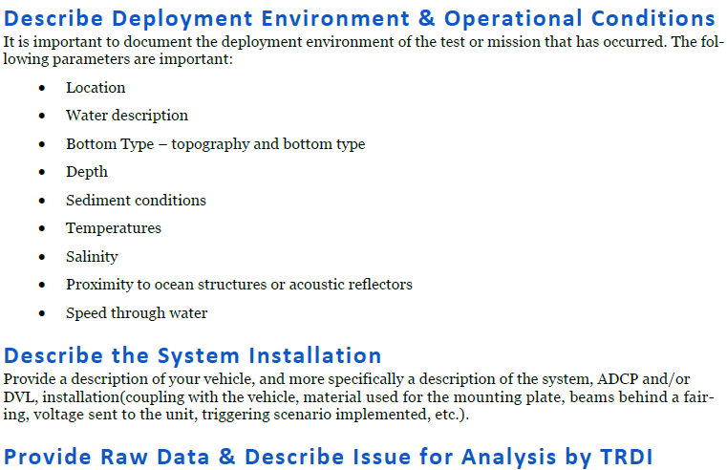

The commands shown are the minimum commands that should be sent to the Pathfinder. Page 65

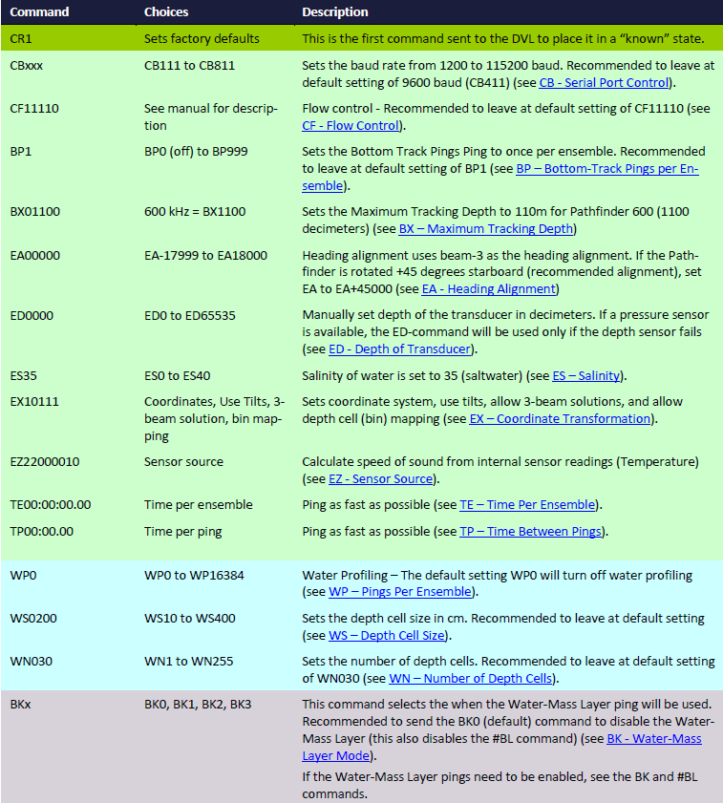

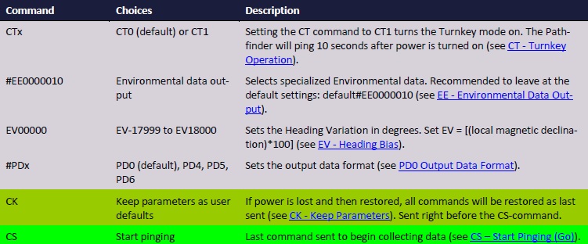

Which output forma should we choose ?

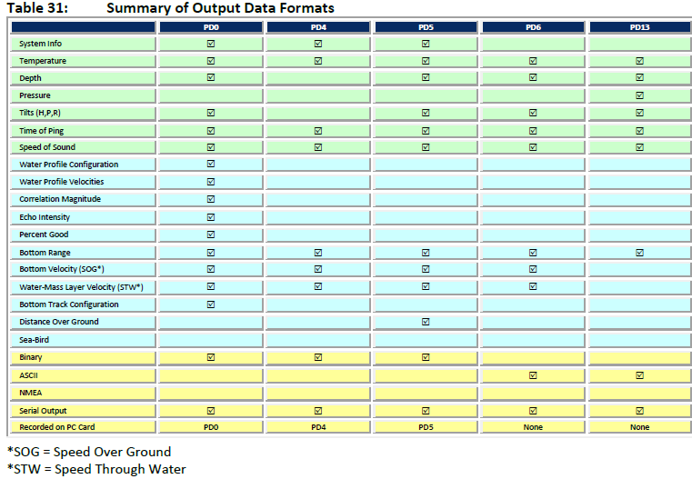

Pathfinder measurements suffer from occasional data outliers which, although rare, can still be far more frequent that would be expected from a normal (Gaussian) probability function. To prevent the navigation system from giving undue weight to data outliers, it is important to screen the Pathfinder data to detect and reject them.